*The Conglomerate* September, 2022

***Davis Creek Rainbow Obsidian and Oregon Sunstones***

***Hilary Loupee, RGMS Board Member at Large***

Davis Creek is open again! Once I heard the news, I wanted to get there as soon as possible. I ran into Spencer at the shop, and he was also trying to plan a trip, so we decided to go together. Find- ing digging buddies is one of my favorite things about RGMS. For those of you familiar with the old Davis Creek permit system like I was, things have changed a bit. Obsidian-collecting permits are only issued from the Modoc National Forest Headquarters at 225 W. 8th Street in Alturas, California, M-F 8-12 and 1-4. That means if you want a weekend permit, you still have to get there early enough on Friday. And they only issue 25 permits a day, so there is the possibility that you could drive 3 hours up there and be out of luck. But thankfully, they told us on the phone that they haven’t quite reached the limit even once this season, so we decided to get there at 8am on a Friday morn- ing with fingers crossed.

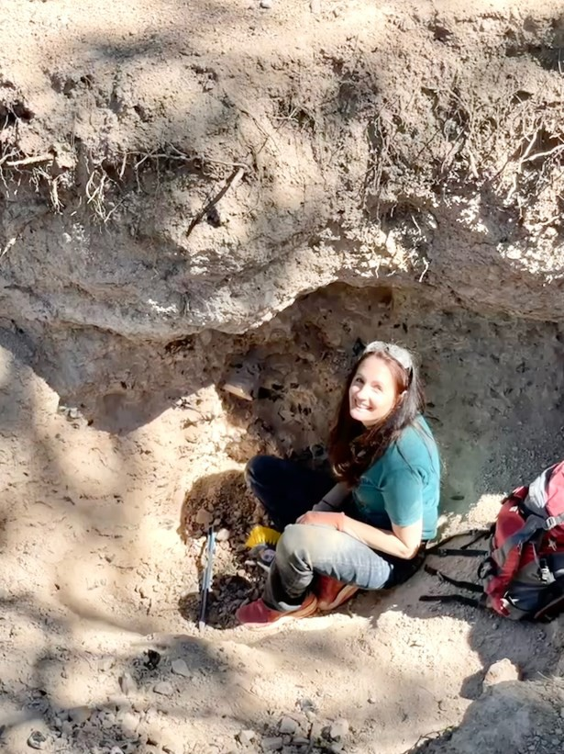There was only one guy already waiting when we pulled up at 7:50am. You are allowed 3 permits a year, but since the season is currently only July 1st – August 31st, we didn’t think we’d be back this year and got permits for Friday and Saturday. This involved a LOT of paperwork by the lady at the desk. I miss the old days of getting permits at the Davis Creek Mercantile. Each current permit al- lows you to fill two 5-gallon buckets on the day the permit is issued for. You can dig at any of the 4 mines – Rainbow Mine, Pink Lady, Middle Fork Davis Creek, and Obsidian Needles. Collecting out- side of these areas is not permitted. The forest service office will give you some good maps for the area, although don’t expect anything to be marked once you are out

there. We found the best way was to really pay attention to the mile- age and use Google maps to track your location on the roads. Even without cell coverage, Google maps still works a little bit.

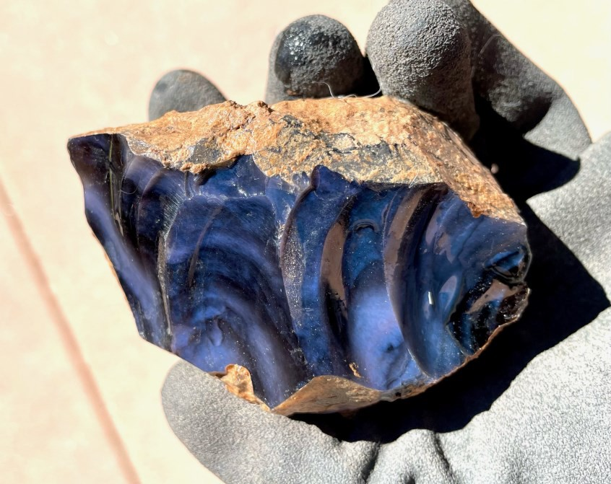With permits in hand, we first headed to the Rainbow Mine. From ex- perience, I knew that this

mine produced (in my opin- ion) the best material, but it was also miserable clay dig- ging. I thought we should attack this with the most en- ergy and while it was cooler. Sure enough, less than an

Hilay digging in the clay

hour into the dig, I had a small

pile of exceptional pieces including the unbelievable elec- tric blue piece pictured. It’s even more stunning in person.

Not too long after we arrived, a ranger showed up to check our permits.

Electric blue obsidian

She was super friendly and chatty and couldn’t stop picking up pieces off the ground herself.

Continued next page

A Member of CFMS and AFMS Page Five

Once we’d exhausted ourselves in the clay, we headed down the dirt road to the Pink Lady Mine, which was about 12 miles away. The final turn into this mine is onto an extremely narrow dirt road to the left, and we completely missed it. A little farther down the wrong road we ran into a family that had also missed the turn. After looking at maps with them, we backtracked and found the road we wanted. At first, the Pink Lady Mine seemed like a big disappointment as none of us were finding much color. The way to check for rainbow obsidian is to hold up a piece in the sun. If it’s not already broken, you may need to chip off a piece with your rock hammer. Eye protection and gloves are a MUST! The colors will only appear on one angle, so if you break it and see bands, that means you need to break it again at a 90 degree angle to see the color. A water bottle to spray does help to see the color a little easier.

*The Conglomerate* September, 2022

I started digging in an old hole and began popping out some really nice rainbow pieces with multiple colors. From the name and reputation, I had thought everything here was only pink. Philipp started digging in the soft dirt under some pine needles and was digging up chunk after chunk of pink obsid- ian. Spencer and I joined him and every single piece we dug up was pink. We stopped breaking them at some point because they were so consistent!

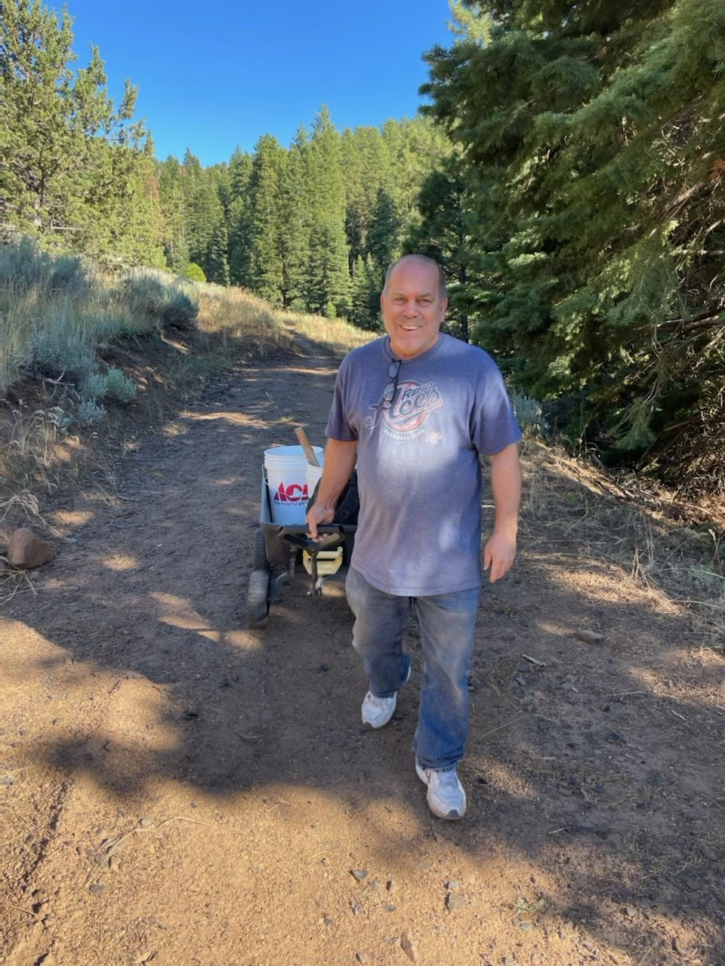We decided we’d better get to the other mines and headed over to Middle Fork Davis Creek. I’d been there in the past when it was a commercial operation and we were allowed to dig in the tailings. They’ve blocked off the road now, so it’s quite a little hike up the hill to the collection area, and it’s another feat to car- ry your obsidian down. The largest pieces are typically found at this mine, so it’s a good bet if that’s what you are after. We found some really nice pieces, but we were all getting tired and decided to head to camp.

There are several nice campgrounds in the immediate area and we camped at Plum Valley. There is a little creek running be- hind the campground, a vault toilet, and fire pits. It’s only a mile off the main road to the obsidian and just down the road from the Mercantile if you need supplies.

The next morning, since Philipp had to get home, we decided to

go first to the sunstones just north of Plush, Oregon. Make sure you have maps loaded before you head out from Alturas, as there is no signal anywhere from Alturas to Plush or anywhere

Spencer walking up to the Middle Fork Da- vis Creek Mine

in Davis Creek. Without maps, we struggled a little, but found our way to the sunstones with only one wrong turn. Plush is about an hour from Davis Creek and sunstones are basically 20 miles north on the Hogback Road out of Plush. After 9 miles, watch for a tiny sign indicating a right turn. We missed the sign because a trailer was stopped in front of it. From there, you can follow other signs all the way in.

A Member of CFMS and AFMS Page Six

Sunstones we found

At the sunstones, there are tons of fee-dig places that offer con- veyor belts of rocks to pick through, but I’ve never found them to be better than just digging on the free BLM land. There is a good camp area with a toilet and some shaded picnic tables, but no trees. You can collect all around this area. It is perfect for surface picking, although we opted to try to sift the dirt to maybe find unex- posed sunstones. You do have to walk away from the parking area as it is very picked over right in the immediate vicinity. We brought sifting boxes, although I found my combination of the green classi- fier (sifter) that a lot of us have and a regular plastic kitchen colan- der worked like a charm. The larger classifier caught the big rocks and the kitchen colander let the sand out, so only sunstone sized rocks were left in the colander. Be sure to glance at the larger classifier though, as several times I caught a big sunstone in it!

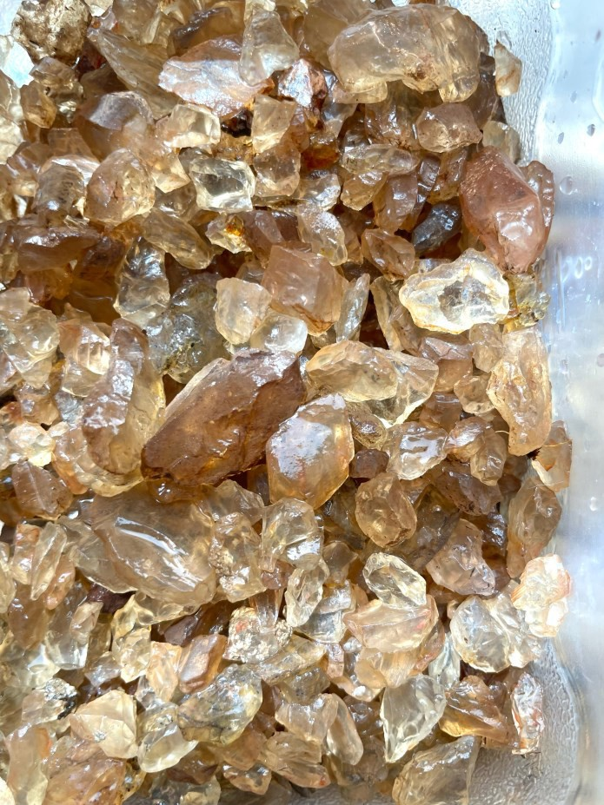We only spent a few hours at the sunstones and then headed back to Da- vis Creek to get our permit limits for the day. Since it was already after 4

when we got back, we decided to head to Philipp’s spot at Pink Lady and take some easy pick- ings. We found some very sizable boulders there that filled up our buckets rather quickly. With the car loaded and riding low, we decided not to go up the very steep and windy road to the Obsidian Needles. That road requires a high clearance 4WD vehicle. I’ve been there before, and it’s mainly to get some specimen needles. There is a lot of mahogany obsidian as well as the occasional rainbow piece.

*The Conglomerate* September, 2022

Everyone in the group was thrilled at their findings and decided to head back to Reno. We had planned to camp again, but opted to make the 3-hour drive home for a comfy bed. We stopped in Alturas for some surprisingly great pizza before heading back. I can’t wait to get some of the piec- es cut and I’m sure you’ll all be seeing some of it in the RGMS online auctions. I would like to pro- pose this trip as a field trip for next year. The concern would be the 25-permit-a-day limit, so we’d have to limit the number of people and alternate with one group on sunstones one day and rain- bow obsidian the next, but I think we could make it work. I found out from the chatty ranger that a family can also share a permit for their 2-bucket limit, so that would allow more people to go. If you are interested in doing this or want more info before making your own trip, feel free to reach out.