THE HUMAN RACE IS IN DANGER FROM MOTHER EARTH

D.W.Webb Varnum

On Television and the news there are discussions about how a supervolcano could bring about the end of mankind. There are 12 super-volcanos in the world. If any one of these super-volcanos did a complete emptying of its lava chamber, the effects would end the modern world as we know it: the dust cloud would last five to seven years, most plant life would succumb, leading to the extinction of many types of animals, including humans. There would be much violence and suffering.

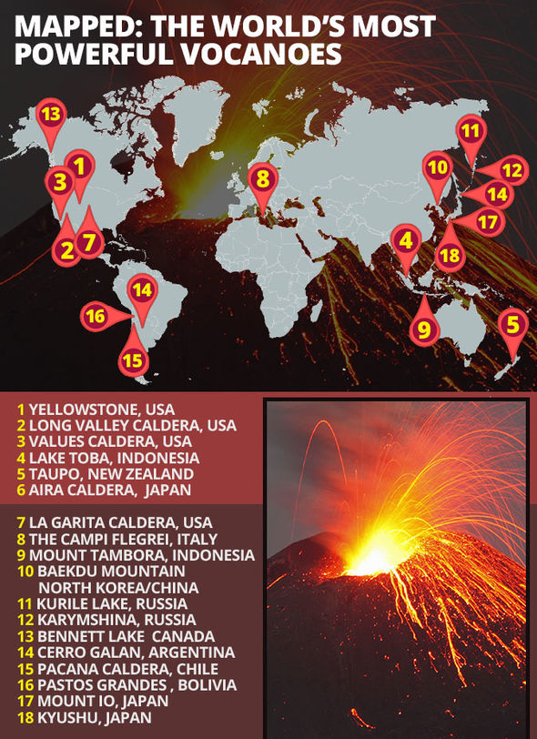There are four of these super-volcanos in the United States: two are presumably dead and totally inactive—one in western California and one in New Mexico. Two others show signs of activity--one is Yellowstone, and the other is in our own back yard. It is at Mammoth Lake where many of us go to play, and its name is the Long Valley Caldera.

This caldera is known as California's Yellowstone. Why is it here? Because we live near the edges of tectonic plates, the Continental Plate, and the Pacific Plate. The Pacific Plate is being forced down and under the Continental Plate, causing great heat.

|  |  |  |  |
| --- | --- | --- | --- |
|  | Long Valley | Yellowstone | Mt. St Helen |
| Last event | 76000 years ago | 640000 years ago | 42 years ago |
| Size | 20X11 mi | 35X34 mi | 1.2X1.9 mi |
| Depth | 300 ft | Several thousand ft | 2084 ft |
| Ejection | 140 cu mi | 240 cu mi. | .29 cu mi |
| Dust Cloud | 8 mi | ?? | 6-8 mi |

Some comparisons:

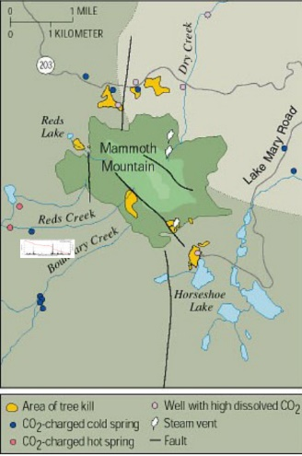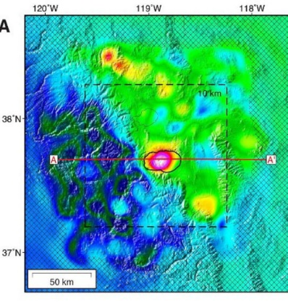There are other active Ring of Fire volcanos along the west coast of the U.S.A. Mt Lassen erupted in 1914,1921, and 2014. Also the giant Mt Rainier was active in 2021, and Crater Lake has been showing some activity. It seems that Long Valley is also waking up! How do we know? An increase in geothermal activity has been recorded--new smoke and carbon dioxide are both venting and killing trees. Worse yet, the CO2 is heavier than air and flows down hill, so in addition to killing trees, it can fill valleys, killing all animal life including human life.

Even more alarming is the resurgent dome near Bishop that is pushing up noticeably in the last few years. In 2018 the Long Valley deformation was measured by the earth’s magnetic field, proving the presence of a large magma chamber estimated to contain 290 cu miles of melt. This is an indication that there is a large amount of liquid below the surface. Another sign is earthquakes; after a period of relative calm, the swarms have increased in the last 20 years. These quakes are usually of a magnitude 1 to 1.2 at a depth of 1Km to 23Km .

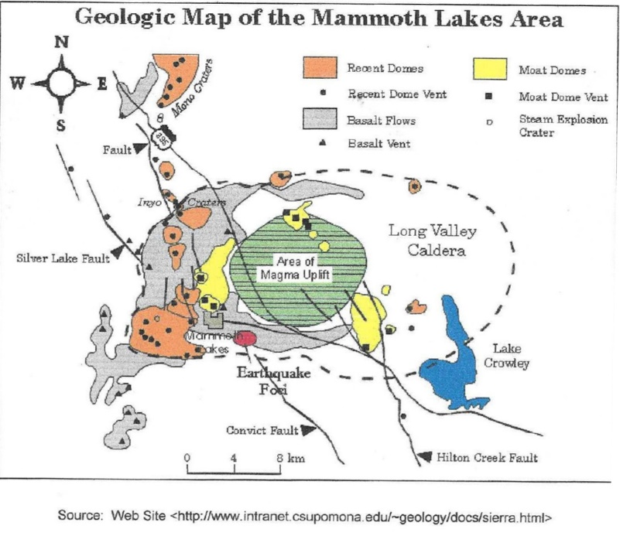There are several other points of geologic interest In the area. There are two volcano cones in Mono Lake—first, Negit Island, which erupted 300 years ago, is an intrusive rhyolite dome. Second, Paoha island, an intrusive basaltic dome which erupted about 13300 years ago. There is also another cone to the south at Mono Crater.

Besides the dust cloud, other dangers of a volcanic eruption include lava temperature close to 2000+ degrees, pyroclastic flows carrying dust super-heated to 800 degrees and moving at speeds to 500 mph,. With snow covered volcanoes such as Rainier or Mammoth Mountain, the danger can include lahars , which are flows of water and ash similar to a giant mud flood that destroys everything in its path.

Here is how the USGS puts it: “Increased volcanic activity in Long Valley area since 1980 increases the chance of an eruption occurring in the near future, but scientists still lack adequate data to reliably calculate by how much. Volcanic unrest in some other large volcanic systems has persisted for decades, even centuries, without leading to an eruption. But since volcanic unrest can escalate to an eruption quickly – in a few days, or less--USGS scientists are monitoring the activity closely.”

Is there anything we can do?, Can we prepare? NO. All we can do is just to hope that any such event is far, far in the future.

Source: all images, drawings, maps, and data taken from USGS web sites